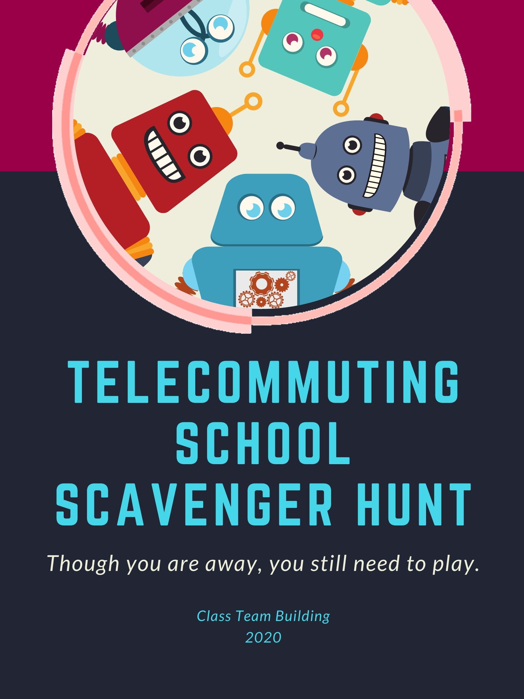

Overview:
We want to provide something fun to help your school staff get through this less than ideal situation, while keeping it quick and easy to run as an administrator, because no doubt you’re busy too.
We DID NOT try to overcomplicate this. It is super easy and super flexible: Two things every administrator needs right now. We kept the focus on providing smiles and fun for the staff. There will be plenty of time when schools reopen to get back to our full, professionally produced school culture programs.
For this one, you simply copy the emails and edit any scavenger hunt items to make them more specific to your school.
If you have questions, please email support@classteambuilding.com
Have fun!

A note from Class Team Building:
Many schools are finding out about us for the first time right now, and if you haven’t joined Class Team Building yet, you really should.
We make it affordable and easy for administrators to grow positive school cultures and staff morale, and the glowing reviews from our members speak for themselves.
Just like everyone, we’re adjusting to school closures, and we wanted to get this Scavenger Hunt out to you quickly. However, we’re also busy converting some of our professional-level programs to work remotely too, including a The Ultimate Teacher Appreciation Week Game Show and an End -of Year Saturday Night Live survey, both of which quickly revert back to normal if schools reopen.

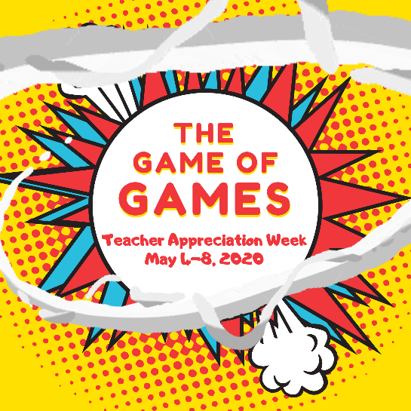

Please use this scavenger hunt to give your staff a much needed fun distraction, and we would love to have you join us as members. (See back of packet for membership options)
Thank you, everyone, and have fun with this!
-Class Team Building

Instructions
Teams:
The teams will be comprised of teachers, but the teachers are then free to get the students involved too, as they see fit (assuming the teachers are still in online contact with the students).
There is a space at the bottom of the introduction email for listing the teams, and we’ve defaulted to forming them by grade levels for simplicity, but you are free to mix it up if you wish. Everyone is welcome to play, so you can add office staff or anyone else who wants to play to a team also.
We’ve provided score sheets for up to 15 teams, though it’s possible to add more if needed.

Scoring:
Download the Score Sheet file to help you easily keep score. This is a spreadsheet file with one tab for each team.
The first tab, the Team 1 tab, is the Master Tab, meaning any scavenger hunt item you edit on it, will also automatically change it for all other team tabs.
Therefore, if you want to change a scavenger hunt item before sending out an email, change it in the email, but then be sure to also change it on the first tab of the score sheet file as well, which will update the item on all the team score sheets.

Introduction Email:
This is the email that explains the situation and the rules of the game. Edit this to fit your style, then send the afternoon before you begin.

Morning Emails:
We’ve provided you an email to send out each morning. Edit this email any way you wish, including changing out any of the scavenger hunt items. We encourage you to switch any item you don’t like for one that is more specific to your school. In fact, the more specific you make it, the more you add items that make you laugh, the better the scavenger hunt becomes.
Since this version is all through email, the teams will be sending you digital pictures and various other items that you can paste and share during the following day’s email.
Introduction Email. (Copy this text to your email, edit it to your liking, and then send out to all the staff):
Hello Everyone,
Growing up, every time the power would go out, my family would light some candles and grab a deck of playing cards or a board game. It was our way of making the best of any situation, and we had some great times.
Looking back, even though I always grumbled and complained at the start, it was those less than ideal situations (power outages) that ultimately brought us closer together as a family.
So, I’ve been thinking, why not take a page out of my family’s playbook and create a game for us to lighten things up? (Wait, did I just hear some familiar grumblings, hahaha)
I’ve decided to call it, “THE ULTIMATE REMOTE DAYS SCAVENGERHUNT!” -- It’s a working title, but I kind of like the acronym
Here’s what we’ll do. We’re going to use our grade levels as teams, with a few adjustments, and I’ll have some mystery prizes for the top 3 teams, not to mention bragging rights.
Rules
I’ll email out a list of items/challenges tomorrow morning with a point value next to each. For each item your team acquires, you’ll get that number of points, with bonus points available if your submission makes me laugh or if it is of very high quality. I’ll also be sharing some of the best submissions with everyone, and if your team has one featured, you’ll get 5 bonus points for that too.
Simple, right?
The game will last for 3 days, with new lists emailed out each morning. Some of the items might be tasks, some might be pictures, and some might seem quite strange, but I assure you there is a method to my madness!
You are free to go about acquiring the items however you wish, including recruiting students to help if appropriate. I only want one submission emailed to me for each team, and the deadline is 4PM each afternoon.
And let me just say this, for the ultimate winning team, you’re going to LOVE your prize!
You’ll receive your first list tomorrow. Thanks everyone for participating and let’s have a little fun. Good luck to everyone!
Here is the list of teams:
(insert your team list here
Team 1:
Team 2:…)
1st Morning Email:
Hello Everyone,
It’s game day!!
If you don’t know what this is about, go back and look through your yesterday’s emails where I basically instituted a family game night
Here’s your first list. Your team doesn’t have to find everything, but the more you obtain, the more points you’ll earn. For any team that submits everything, I’m doing a 5 point bonus.
2 points: Favorite sentimental picture from August – November, with caption. (For items like this, please just pick out your team’s one favorite to submit. And remember, you may also ask students for submissions.)
2 points: Favorite funny picture from August – November, with caption
2 points: Picture of how many toilet paper rolls you have in your house (the most rolls wins, but PLEASE don’t go out and buy more!!)
2 points: A creative nickname for me. (step lightly!)
3 points: A picture of someone on your team demonstrating your idea of “proper telecommuting work attire”
4 points: What was the Dow Jones Industrial Average at 2:15PM today?
4 points: Reading from left to right, top to bottom, what is the 85th word on our school website homepage?
2 points: If you had no water and no hand sanitizer, what is the best way to disinfect your hands? (looking for creative answers)
4 points: A picture with someone on your team wearing a big hat. The biggest hat wins bonus points.
3 points: Your one best piece of advice for the administration for the upcoming year (serious or funny)
And finally, 8 points: Fill in the blanks for this caption and provide a picture or video to go with it, “It was day ____ of the quarantine when ______ .”
Remember, email me your team submissions by 4PM, and I only want one submission per item. Got it? In other words, I don’t want your team to submit 8 pictures for the same item, I just want the 1 best picture.

Good luck, everyone, and thanks for participating. I can’t wait to see the submissions!

2nd Morning Email: For one of the main items on this list, the crossword puzzle, we’ve given you instructions on how to make it online, easy and free. You will find these instructions on the next page. Of course, if you don’t want to do this, simply switch out or delete the crossword item.
Hello Everyone,
Hahaha – nice job yesterday! This scavenger hunt is going better than I expected. Here is today’s list, followed by some of the best submissions from yesterday. Remember, you don’t have to obtain everything, but the more that you do get, the more points you score!
20 points: A screenshot of the completed crossword puzzle found at this link. I’ll give partial points based upon how much you were able to complete: (insert puzzle link here)
2 points: Your favorite sentimental picture from December – February, with caption
2 points: 3 book recommendations, with creative explanations of why you recommend them
2 points: Complete this sentence: (insert name of male teacher here) said one time he washed his hands at school and we were out of paper towels, so walking down the halls, he dried his hands on _____ instead.
3 points: The CUTEST picture of you with a pet.
3 points: A written description of the most drastic thing you did to prepare for social distancing
2 points: A picture of the very last thing you would eat before you totally ran out of food at your place.
5 points: Send someone not on your team a nice, digital, pick-me-up. Could be an e-card, virtual flowers, or something creative or custom you come up with yourself. Once complete, write up a description. The nicer and more creative it is, the more bonus points you’ll earn.
2 points: What should one of tomorrow’s scavenger hunt items be? Bonus points if it actually makes the cut.

That’s it for today! Be sure to have your team submissions in by 4PM.
Let me share some of the best submissions from yesterday. (I love these!):
(insert any fun or funny submissions here)

Creating your school crossword:
Prep Time: 20 minutes
Instructions: We’ve provided a quick, easy way to create a custom crossword puzzle about your school for free. You fill in the clues and answers, and the website automatically creates the puzzle. You can copy a link where people can play it online.
- To create your puzzle, go to: www.shareapuzzle.com and click Login. Enter our email address to use our account so that you don’t have to pay a thing: support@smartteambuilding.com
- You might see other puzzles from other schools listed in the box, but please don’t select or change them. Instead, click on Start a New Puzzle on the bottom left hand corner.
- Enter a title and subtitle that include your school name so you can find it in the list. We suggest something like, “Title: Northside Elementary. Subtitle: Scavenger 2020.”
- Don’t preload a theme. (This option automatically enters themed clues that we don’t want.)
- Enter your clues and answers. We suggest making 20 to 30 clues. Making them specific and tastefully humorous about your school is always a good idea, plus adding random trivia about the school is good too. Don’t be afraid to make some of them difficult, though not impossible, because we want them to be asking each other for help with clues. That’s all part of the fun.
If you’re having a hard time thinking of clues, a good way is to write down a list of words related to your school, THEN think of creative ways to clue that word.
Here are some examples from one school to get you started:

- Mr. Melvin’s start of day: sixam
- 3rd essential of teaching: students, material, ________: coffee
- Our longest tenured: Pirkle
- “Red Papa”: mrleonard (this was this coach’s nickname)
- 2015 star: Carter (Carter was the 2015 Teacher of the Year)
- Time Mr. Melvin wishes he arrived at work: twofifteen
- What cheese is: Cheese (This is from an inside joke from the school. Maybe you have some of those for your puzzle. One strategy is to use a good natured inside joke that only some of the staff would understand, so that people start asking each other if they know the answer.)
- Bringer of lunch smiles: pizzaday
- Number of bushes within 20 feet of the front entrance: zero
- Kelly, Morgan, Tara, et al. : cheerleaders
- We don’t want them: leftovers (another inside joke. We think these are great for the crossword clues if you have some)
- Last 2018 snow day: apriltenth
For scoring, our suggestion is that you don’t worry about checking every last entry in the puzzles for correctness. If they look complete when they turn it in, they get 20 points. If it looks incomplete or you notice some incorrect, you can partial points.

3rd Morning Email:
Hello Everyone,
This is the last day for the scavenger hunt. We will have the results and announcements tomorrow.
Thank you all for your participation. I love it! Good luck to all the teams; it’s still anybody’s game! Here is today’s list:
4 points: PUZZLE CLUE: Take a picture next to yuftorodonro (DELETE THIS EXPLANATION BEFORE EMAILING: This spells “Your Front Door” scrambled up.)
4 points: Does someone on your team look like a celebrity? Find a picture of that celebrity and then take a photo of you looking like that picture.
3 points: 3 little known Netflix or other streaming shows you recommend, and your creative reviews to go with them
2 points: Your favorite sentimental picture from March, with caption
2 points: Your favorite funny picture from March, with caption
2 points: Send me the name our youngest staff member
2 points: A description of your favorite class assignment and how it went this year, with picture if you have it
3 points: A written description of your favorite cabin fever remedy
(Yesterday we asked the teams for any scavenger hunt item ideas. If you had any good ones, insert them here)

Let me share some of the best submissions from yesterday. (I LOVE these!):
(insert any fun or funny submissions here)

4th Morning Email (Last day, includes our prize suggestions, but certainly you may change the prizes. Online or Amazon gift certificates are always a hit if you have the budget):
Hello Everyone,
I’m officially calling the 2020 Scavenger Hunt closed!
Thank you so much for helping me out with the scavenger hunt. To be honest, I mostly wanted to send something out that would generate something positive, and seeing all these photos and submissions did exactly that. I hope you had some fun too.
Below I’ve copied even more of the best submissions. Do they make you smile and laugh as much as me?
And here are the scores, winners, and prizes!
3rd place: _______ PRIZE: Work from home for a day! Just kidding… too soon?? Your team gets a “Leave 15 Minutes Early” pass once school reopens.
2nd place: _______ PRIZE: $200 for each of you! Haha, only kidding again. Your team gets a “Leave 20 Minutes Early” pass once school reopens.
1st place: _______ PRIZE: Well here it is, the big one. The one everyone has been striving for all week. The first place prize, in the 2020 Scavenger Hunt is…. Drumroll please… Your team gets a “Leave 25 Minutes Early” pass once school reopens, ANNNNNNND… you get to choose a song for me to sing on a video and I’ll send it out to all our staff!!! (Any song you like, so long as it’s appropriate… )
That’s it! Look out for the video, and thank you, everyone!!!

Information on Class Team Building Membership
Building and maintaining a great school culture is an ongoing process, so we guide you through every step. Each activity is different and will have everyone interacting, laughing, and filling your halls with smiles and kindness.
Everything is built around the typical school calendar and focuses on different areas each time. You’re always in control and able to schedule, delay, or skip activities whenever you need.
You’ll have expert activities for:
- On-boarding new staff and welcome back in August
- Classroom builder for students for September
- Leadership jump-start
- School-wide Principal’s Book of Secrets adventure in October
- Student conflict resolution
- The best holiday event EVER!
- National Teacher/Student Scavenger Hunt lesson booster
- Staff stress and cabin fever relief in February
- Student winter doldrums buster: The Game of Games!!
- The ultimate Teacher Appreciation Week
- End-of-year review, survey, and SNL skit
- Plus multiple ways to boost everyone’s morale whenever needed.
Your time is freed up to run the school, knowing that your staff appreciation, team building, and morale are in good hands.
You’ll know these programs each have a specific purpose, but everyone else will simply see them as the amazing and fun activities their awesome school and administration does. Come May, you’re going to be hearing a lot of, “That was the best year we’ve ever had!”

Easy ways to join Class Team Building.
If you’re not a member yet, we would love to have you join us, and for those of you who join in the next few weeks, we’ll give our biggest discount ever.
These are tough times for all of us, and we’ve discounted the membership 30% for those who lock in this rate for 2020-2021. This is the biggest discount ever for Class Team Building, (and the most we can offer and still pay our staff). This discount will be good for the life of your membership, making now the best time to take advantage of the savings.
OPTIONS:
- $39/month
No contract. No cancellation fees. Just our biggest discount ever (normally $59/month).

- Prepay for a year at 30% OFF
Comes to $455. Email us at support@classteambuilding.com to be invoiced. We accept all payments: checks, credit cards, and PO’s. We are also happy to work with you and delay invoicing if your school district is closed or on budget freeze.

- Get it done now with quick email to parents or social media to crowdsource your membership with Teacher Appreciation Week messages. (Averages a 14 month membership.) Copy the email below and email it to parents, PTO/PTA, or post it on social media. Obviously feel free to edit and adjust to your style and liking:

Hello everyone,

I recently learned of an organization that provides the same morale and team programs that big corporations use, but they’ve converted them to work for students and teachers, and they have amazing results and reviews. I would LOVE this for our school and was hoping we could quickly crowdsource this with $10 or $20 contributions (it would only take 50 of us to contribute $10 to get us a whole year). Because of everything happening, they’ve set up a site to contribute for schools, and it’s at a 30% discounted rate: https://www.classteambuilding.com/drive1 .

When you contribute, there is also a space for leaving a custom message, and with Teacher Appreciation Week coming up, I thought it would be a good opportunity to write a very short note to a teacher of your choice, under 150 characters. I have an idea of something special to do with these if we get enough.

Thank you, everyone!

