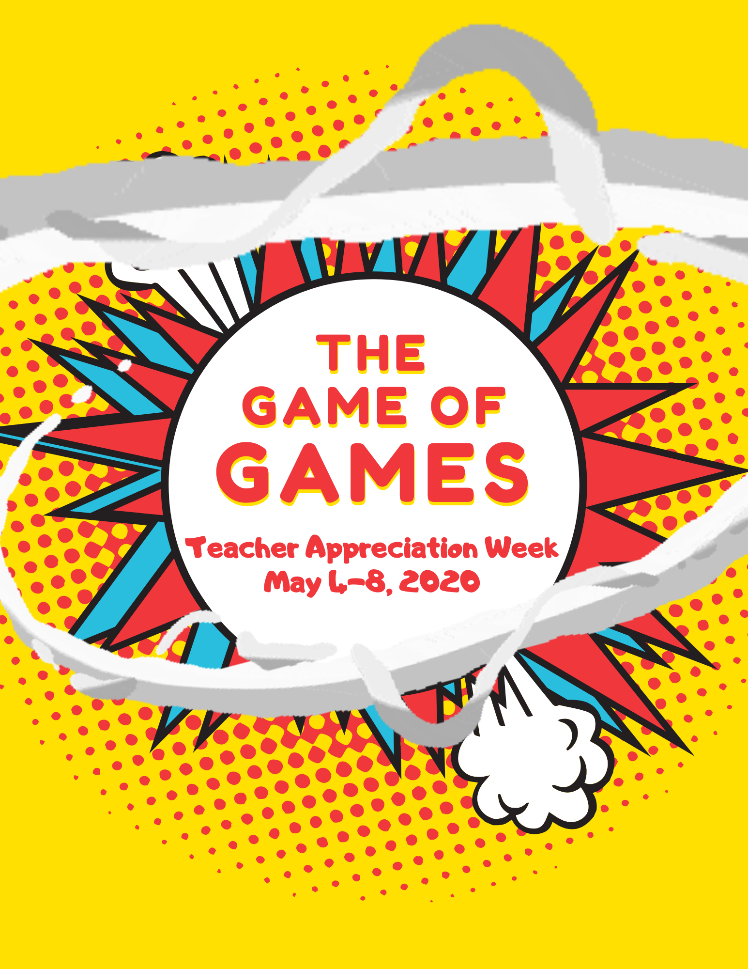
Classteambuilding.com
© Athlon I.A., LLC 2020

*If your school reopens before Teacher Appreciation Week, this activity can quickly be converted to work with teachers back at school. Email us at support@classteambuilding.com .

Overview
We want your teachers to have an amazing week, full of laughter and smiles, and this packet makes it super easy for you to pull off.
This game is an excuse for you to hand out prizes and appreciate your staff while having a lot of fun in the process. We’ve provided a link to an online wheel and given you several options for how to play remotely. Each teacher will be allowed to spin the wheel once a day, and it will either land on a number or a prize. If it lands on a number, you look up that number in a list of challenges, and then the teacher must do whatever the challenge says to earn points and win the game.
The challenges are all over the place, but they generally are either things that will build goodwill or off the wall ideas that also bring people together. Plus, you get to add and edit the challenges to make them fun and specific to your staff.
Play runs for four days and on that last day, for those who like to go above and beyond, there is an optional bonus round with extra prizes and fun.
For the prizes, we’ve provided a Prize Guide that makes everything easy. Prizes don’t have to be extravagant, and we’ve included pre-written emails to parents and businesses to see if they would like to contribute e-gift cards (it doesn’t take many to have enough for the whole game) plus prize coupons for creative school privileges that won’t cost you anything.
Telecommuting and social distancing certainly added some challenges, but we love this program because it is one of our most flexible. Not only do you get to choose how to setup the game and edit the activities, but you can customize almost any aspect of it to meet your school’s needs. If you have questions, or would like suggestions for any special circumstances, please email support@classteambuilding.com.
Have fun!

Instructions

Step 1: Review, edit, and print the “List of Challenges” file.

This is the heart of your game, and the better we make this list, the better your week will be.

When a player spins the wheel, it will land on a number which you will look up in this list. If they complete the challenge next to that number, they will get 1 to 10 points, depending upon how well they execute it.

It is ok for more than one person to land on the same challenge during the same day. Challenges can be completed by more than one player at the same time.

Go through this list and edit it to make it better for your school. Some notes to consider:

- We are unsure what your state or local social distancing guidelines will be like during your week, but all the challenges are social distancing approved as we write this. Adjust as you see fit.
- Making the challenges specific to your school makes them more fun and effective. This is our number one, best suggestion. If the challenge says, “Do someone a favor,” it’s much better for you to change it to, “Do Mrs. Jones a favor.” Go through the list and each time you see the word “someone” underlined, that means it’s a good place for you to change it out to a specific person. Don’t stop there. Go through all our suggestions and try to make them more specific to your school or staff.
- We want the challenges to excite the player when they first hear it. If you don’t like a challenge, change it. This is your game and hopefully our list will inspire you to make some creative ones of your own. In fact, the more you make your own, the more specific you are able to make them for your school, the better the game will be.
- If you do like a challenge, copy it and use it for more of numbers. Having repeats is fine.
- Telecommuting is new to all of us. Our team will continue thinking of new and better challenges all the way up to May 4th. Get updated ideas and share your own with this online list for members: https://docs.google.com/spreadsheets/d/1yqwuxRJt5EEq_8qCEayKJHtAcW2TpHBcq6tZPS72sMk/edit?usp=sharing
- Try creating new challenges for each of the 3 days you play, making them as specific to your school as you can. Example: If someone’s birthday happens to be one of those days, create a challenge to get everyone else in the school to text them birthday wishes, or if a particular challenge went well on the first day, try to evolve it slightly and make more of them for the 2nd day.

Step 2: Arrange some prizes and personal thank you notes from students and parents.

Open the “Prize and Thank You Guide” file and decide which sections you would like to use. We recommend you do this as soon as possible, just to give yourself enough time. Everything is through email and online, so while it’s better to have more time to dedicate to these prizes, you should be fine even if you start with just a few days to spare.

There is a companion “Prizes and Thank You Organizer” file. This spreadsheet makes recording, organizing, and printing the submissions easy. Directions for this are in the Prize Guide.

Delegating one person to oversee prizes and thank you notes is an effective strategy here. It’s not hard, but keeping things organized is key.

Step 3: Decide the best way to set up the wheel and execute the game show.

Social distancing and working from home have required this extra step, but we’ve provided several options so you can pick out which you like best.

The wheel runs on a webpage on our site: https://www.classteambuilding.com/wheel032522schoologin Use your email as the password.

Everyone may make one spin per day. Normally, with teachers in the building, schools set the wheel webpage up on a spare computer in the office and let teachers spin it themselves as they arrive to work. However, with this telecommuting version, we want to find the optimum way for your teachers to spin the wheel and have fun while maintaining proper social distancing protocols.

We’ve developed four options for you. You will find more details and specific instructions for each one in the “Wheel Setup” file.

Option 1: Drive-thru Game Show.
To be honest, we have no idea what the federal or state social distancing recommendations for your area will be on May 4th – 8th, but if they allow for people to drive through your school parking lot while staying in their car and maintaining 6 ft of separation, then we highly recommend you consider setting this up as a drive-thru game show.
Hear us out. Though distant, face-to-face human interaction is a great way to reconnect and boost spirits with a bit of silly fun and in-person laughs. And though initially it may seem like extra work to setup this drive-thru, the actual setup is minor, and it saves you from having to do any extra emailing or virtual meetings. Overall, we think it’s the easiest option. Plus, our guess is that by May 1st, anything that saves you or teachers from extra emails and virtual meetings will be a welcome relief.
As they arrive, there are decorations, balloons, pinwheels, “THE GAME OF GAMES” and “Happy Teacher Appreciation Week” signs. They are directed to Station 1 where they are greeted from 6 feet away and given instructions, and maybe asked to tell a little something about themselves, just to get them into the game show spirit.
Then they drive to Station 2 where you’ll spin the wheel and they will be able to see it spin on the computer screen. You will be able to clap and cheer for them as it spins. When it stops, they remember their number and prize result and drive to Station 3 where they are read their challenge, given their prizes, and read a heartfelt thank you submitted from a student or parent.
To us, this is the best option for creating memories and how your school community persevered to do something special during these trying times.

Option 2. Utilize Zoom or other meeting software you are already using.
We want something where teachers can login, see you, and see the shared webpage with the wheel on it.
This meeting version allows the spins to be more social. Teachers join the meeting and are greeted by you or a designated “Vanna.” You spin the wheel and they watch on the shared screen. Everyone claps and says things like, “Big prize! Big prize! Come on Big Prize!!!”
If the wheel lands on a number, look up the challenge and read it to them, or email it to them if it should be kept secret. If it lands on a prize, everyone cheers and you read them the prize and then email it, especially if it is an e-gift with a code.

Option 3: Phone Call Game Show.
This is also a good option, especially if you have a large staff and can’t do the drive-thru or Zoom options. It takes an extra step of organizing people to help make calls beforehand, but then it essentially runs by itself without a lot of emailing.
The idea is that you have a team of assistants, we like to call them Vannas, who are assigned to call the teachers throughout the morning. When they call, they direct the teacher to go online and spin the wheel as the Vanna claps and cheers along during the spin.
If the wheel lands on a challenge, each Vanna will have that list in front of them and can read off that challenge. If it lands on a prize, they will have that information for the teacher as well.
Obviously, it depends upon how big your staff is to determine how many Vannas you will need. Each call will probably take about 3 to 4 minutes. Perhaps just you and your admin team can divide it up, or perhaps you want to ask some parents to help out too. If asking for parent volunteers, planning for each Vanna to call 5 teachers is probably about right.
If you have a very big staff, other than the drive-thru, this might be the best option for you. You’ll need more volunteers to help make phone calls, but once that is organized, it should all run very smoothly without more effort on your part.

Option 4: Email Game Show.
Let’s not over complicate this. It will be fun for the teachers to be able to spin online and report back the results, and then you can reply with their challenge for the day.

Each day the teachers will go online and make a spin. They get extra points if they video themselves really getting into it. They email you the result, and you email them back their challenge and details on any prizes.

We list this as the last option because we really want you to consider the other 3 first. They entail more human interaction and cut down on so many emails. However, we all have to do our best with working from home, and this might be the best option for you. Teachers will still have fun and you’ll still be able to show your appreciation.

Step 4: Scoring and submissions.

Scoring can be fast and furious, but don’t worry.

When people complete a challenge, they will send you some type of confirmation, either a photo or other submission to be score 1 to 10. Save the best of these submissions to copy/paste into the next morning’s email (more on this below).

But…to be honest, we are only keeping score to find the ONE PERSON who does the best! We’ll leave it up to you if you want to keep perfect scoring records or not. For most of you, to make it easy, simply keep records of the people who really impress you. Then by the end of the game you’ll be able to narrow it down to a winner. In other words, scoring is subjective, so don’t knock yourself out trying to keep perfect score.

The main reason we want people to send you their photos and video links is so that you can share the best of them at the bottom of each morning’s email. This is a great way to reconnect and keep your school community interacting and seeing each other’s faces.

As submissions come in, don’t feel like you have to save them all. But if something makes you smile or laugh, copy it, paste it into a document, and then copy them all into the bottom of the next morning’s email so everyone can see and share.

Step 5: Assemble the assistants!

Sure, you could implement this activity all on your own, but what fun is that? Having a team of 3 or 4 to help you pull this off is a big help.

Here’s an email you can use to assemble your team:

“Hello Team,

Teacher Appreciation Week is May 4-8, and even with the current unfortunate circumstances, I want to make sure we do the absolute best we can. I’ve obtained a telecommuting Teacher Appreciation Week Game Show that is social distancing appropriate, and I’m asking this group to help me pull it off.

I’m attaching the files for everyone, and you can start with the Overview Packet. Nothing is difficult, but if we divide this up and each of us do a really good job with our section, then the whole thing will come out AMAZING!

______, will you please oversee the Prize and Thank You section?
______, will you please oversee the editing the List of Fortunes?
______, will you please take the lead for the section about setting up the wheel? I’m leaning towards us doing _______ .

We can all work together and help each other, but dividing it up this way to start seems like a good idea.

I hope this will be a big boost to everyone’s spirits and fun for those of us setting it up too. We can use this email group to email back and forth about it.

Thank you!”

It’s Go Time!

The following pages guide you step by step.

This game runs for 4 days. The first three days are normal game play, and the fourth day is the bonus round.

Each morning you will send out an email to the teachers, and you may include all staff if you wish.

The afternoon before you start, send an announcement.
(Sunday May 3rd, for most of you). Copy/edit and send this email to everyone.

“Hello All,
Here are some things you might not know about me:
- I always stop to pet dogs,
- My nickname in college was Raspberry Dory, and
- I WILL NEVER FORGET A TEACHER APPRECIATION WEEK!
Therefore, I thought to myself, “How can I possibly make this upcoming week the best Teacher Appreciation Week ever… or at least the best Teacher Appreciation Week ever under national quarantine?? Answer: Turn it into the best gameshow ever… THE GAME of GAMES!!!” (sorry Jeopardy fans)
I won’t go into a ton of detail here, but there will be dares, challenges, prizes, riddles, and ridiculousness of all kinds, but mostly it is going to be my excuse to hand out lots of prizes and show as much appreciation for everything you all do around here.
This is a game format, so of course we are going to have a big prize for the ultimate winner and for those of you who like to compete. However, there are going to be many prizes along the way for all of us, and as an added incentive to cheer each other on, (insert name of assistant principal or equivalent here) has laid down a challenge to provide a bonus round if we all earn enough points as a staff.
The rules: (Depending upon which setup you want to use, drive-thru, online, or Zoom, insert the corresponding paragraph from the “Wheel Setup” file here).
Thanks, everyone, and I look forward to this week and hope we can all share some smiles and laughs.
(If you are doing the meeting or drive-thru version and you have a large staff, use the space below to assign arrival time windows so everyone doesn’t show up at once. If not, delete this.)

The morning you start, send this announcement.
The morning of the start, send out this quick reminder. (If you are doing the Email Game Show option, replace this email with the longer version found in the “Wheel Setup” file.)
“All you party people, COME ON DOWN!!!
Oh wait, that’s the wrong game show.
Let’s try this. It’s time for everyone’s favorite game show…
GAME
OF
GAMES!!!!
As a reminder, our game and my overt appreciation of all of you starts today!
Everyone is allowed to make 1 spin each day to earn cash and prizes… whoops… I mean points and prizes!!
Each day I have some really good prizes picked out, represented on the wheel as “BIG PRIZE!!!” If you land that space, you are one lucky person, but I also have small prizes spread throughout the wheel too.
Now here’s the game part: If the wheel shows you a number, we will look up that number in our Game of Games Challenges, and then you have to do whatever that challenge says to earn points (you know I made all the challenges fun!). Depending upon how well you complete the task, you’ll earn between 1 to 10 points. At the end of the week we have a GRAND PRIZE for the one person who earned the most points throughout the game, and a bonus round if we all earn at least 500 points together as a staff.
To summarize:
- Spin to win prizes.
- Earn points for yourself to try to win the Grand Prize at the end of the week.
- Earn points to try to get us to 500 points as a staff and unlock the Bonus Round.

You can repeat any instructions or time frames for joining the drive-thru, meeting, or when to expect the phone call here.

That’s it for now. I think when you make your first spin you’ll understand what kind of fun this week will be. Thank you, everyone!

Game Day 2 Email
Throughout the week you can send out additional encouraging emails. This is a good opportunity to share some of the pictures, videos, and other content the staff have been sending you from their challenges.

“Good morning, contestants!

There is so much good happening around here. I’m extremely proud and enjoying handing out prizes and seeing everything you all are contributing!!! Let’s keep it up!

This is Day 2, and the spinning continues…

P.S. Day 2 Bonus Points Opportunity – The second day should always be the most civilized. Therefore, we shall all refer to each other by proper names, meaning a formal title with a family name. Example: Sir (insert math teacher name), Earl of Mathematics. Anyone I catch referring to another while using excellent proper form, or if it makes me laugh, or if you talk in a very proper accent, shall be subject to receive bonus points.

Let me share some of the pictures and videos that have come in: (paste the pictures or attach the videos or links.)”

Game Day 3 Email

“Good morning, contestants!

There is so much good happening around here. I’m extremely proud and enjoying handing out prizes and seeing everything you all are contributing!!! Let’s keep it up!

This is Day 3, and we still need points to get to the bonus round…

Let me share some of the pictures and videos that have come in: (paste the pictures or attach the videos)”

4th Day - Bonus Round Instructions and Emails
This round is optional and requires extra prizes, but for those of you who like to go above and beyond, this is the round where you really get to show your school spirit. If you opt not to do it, simply delete the paragraphs in the emails relating to the bonus round and end the game after 3 days without this extra round. Nobody will know and you’ll still have a ton of fun.
Prizes. You’ll need at least one prize for each staff member, and we’ve given you really good ideas and suggestions on how to accomplish this in the Prize Guide file. If you don’t have enough gift cards or certificates to go around, use the prize coupons for things like, “Leave 25 Minutes Early Pass,” or, “Have lunch with the principal when all this craziness is over.”
Having a good mix of prizes is fun, even with some prizes significantly better than others. As the wheel spins, it’s fun for the player to have certain prizes that they are hoping it lands on. Gift cards are especially good for these prizes, and if you have extra ones, you can double up some of them to make them “Big Prizes.” Example: If you end up with extra gift cards, start adding them to some of the prizes. Instead of just one card for the prize, there could be two or three to make it a big, more coveted prize to cheer for.
Send the Bonus Round Announcement Email. We’ve set the storyline around this bonus round as being a challenge from the assistant principal or equivalent. It’s just a fun way to do it, but don’t feel that you need to keep true track of scores to make sure they earn enough. On the afternoon of the 3rd day, send out this email:
“Guess what everyone? Things have been going so well around here, we’ve more than earned enough points to get to the BONUS ROUND!! During tomorrow’s spins, every spin will result in a prize. Be sure to show up with your game faces!”
*If you are doing the email game show option, add this line to the email: “Tomorrow, don’t go to the normal link for the wheel, use this link to get to the Bonus Wheel: https://www.classteambuilding.com/bonuswheel”
Load the Bonus Round wheel. The Bonus Round wheel is found at https://www.classteambuilding.com/bonuswheel.
Number and show off the prizes. If possible we want people to be able to see the prizes available. If most of your prizes are e-cards, then there won’t be much to see. If utilizing a Drive Through Game or Zoom, we suggest you bring out a white board, the bigger the better, and number it 1 to 25. Then write down the prize next to each number and try to highlight some of the best prizes.
How to play and give out prizes: This round uses a new wheel with 25 spaces, one space for each prize. Assuming you have more than 25 staff members, when people win a prize, put someone in charge of replacing the prize with a similarly valued prize until you run out of replacements. After there are no more replacements, if a player lands on a number without a prize, they may elect to move up or down in numbers to the next available prize.

Game Day 4 Bonus Round Email

“Good morning, contestants!

TODAY IS THE BONUS ROUND! You all have earned it, and I’m not just talking about this game. You’ve earned it by working hard all year!

Each spin today is going to be a prize. I hope we have some big winners.

Let me share some of the pictures and videos that have come in: (paste the pictures or attach the videos)”

Wrap-up email and distribution of the personal thank you notes.
On the last day, after the last spin, you may edit and send out the email below.

That’s it! Teacher Appreciation Week GAME of GAMES 2020 has come to a close!

I’ll include some more pictures and videos below, but let’s first get to what everyone wants to know, the BIG announcement…Who is the grand prize winner?!!

Our champion, and winner of the GRAND PRIZE, with a total of ____ points, is ___________!!! You have won ___________________. Congratulations and thanks for everyone who participated and played!

It was a fantastic week! Just what I hoped for. Thank you to everyone for everything you do around here!! You all never cease to amaze me. I love our school family!

(insert a more personal message from the principal here if you would like)

One last thing. I want to share these two documents with you. One is a collection of all the great things parents and teachers wanted to say this week, and one is from businesses and people all over the community. Teaching is a special profession, and you touch so many lives. I hope you enjoy these.

(attach the .pdf files you saved from the Prizes and Thank You Organizer – instructions are in the Prize and Thank You Guide)

Astonishingly fun programs, for both staff and students, to create the school community of your dreams.
If you don’t have a Class Team Building membership, you really should – especially to experience one of our “onsite” programs that isn’t restricted by social distancing.
Hey, we hope you had fun with this Game of Games, but not getting to see our onsite programs is like someone only getting to see your school during distance learning. We do our best, but it’s just not the same as when you get to do our normal, professional-level, proven programs.
Building and maintaining a great school culture is an ongoing process, and we guide you through every step. Each activity is different and will have everyone interacting, laughing, and filling your halls with smiles and kindness.
Programs are built around the typical school calendar and focus on different areas each time. You’re always in control and able to schedule, delay, or skip activities whenever you need.
You’ll have expert activities for:
- On-boarding new staff and welcome back in August
- Classroom builder for students for September
- Leadership jump-start
- School-wide Principal’s Book of Secrets adventure in October
- Student conflict resolution
- The best holiday event EVER!
- National Teacher/Student Scavenger Hunt lesson booster
- Staff stress and cabin fever relief in February
- Student winter doldrums buster: The Game of Games!!
- The ultimate Teacher Appreciation Week
- End-of-year review, survey, and SNL skit
- Plus multiple ways to boost everyone’s morale whenever needed.
Your time is freed up to run the school, knowing that your staff appreciation, team building, and morale are in good hands.
You’ll know these programs each have a specific purpose, but everyone else will simply see them as the amazing and fun activities their awesome school and administration does. Come next May, you’re going to be hearing a lot of, “That was the best year we’ve ever had!”
How to become a member.
Contact us at support@classteambuilding.com
During this national crisis, we are giving our biggest discount ever.
For any school who contacts us before May 15th for membership and mentions this deal, we are giving 30% off for the entire 2020-2021 school year. But you must lock in this discount in before May 15th. Afterwards, we will have to return to normal pricing.

Discount Details:
Monthly membership = $39 (normally $59)
Prepay price = $455 (normally $655)

Contact us for membership
To pay online, or for P.O.’s, invoices, or help because your school district office is closed or on budget free, email support@classteambuilding.com .
Thanks, everyone! We look forward to making this upcoming year great!

