1. The Masked Singer Challenge! Record yourself singing a song, this can either be audio or video, but don’t let it reveal your identity. Send it to me and I’m going to distribute it to other teachers to let them guess. Wow us or make us laugh with you, either way, the more you put into it, the more points you’ll earn.
2. Pick a parent of a student who went above and beyond this year. A parent you wish all other parents could be like. Write a short email to them expressing gratitude for their efforts. Email a copy to me and I will forward it to the parent.
3. Sign, sign, everywhere a sign… Make a yard sign and put it in someone’s yard without them seeing you. Make it sentimental or humorous, big and elaborate or small and sweet, it’s up to you, but we’ll judge your points by how they respond to your drive by signing. Be creative and then be sure to take a picture of it and email it to me.
4. Hungry, Hungry Hippo Challenge. Recreate these pictures to the best of your ability, but with yourself playing the role of the hippo. Please send me the photos.(This is meant to be fun and funny, but if this type of thing makes you uncomfortable, you may replace with the next challenge)
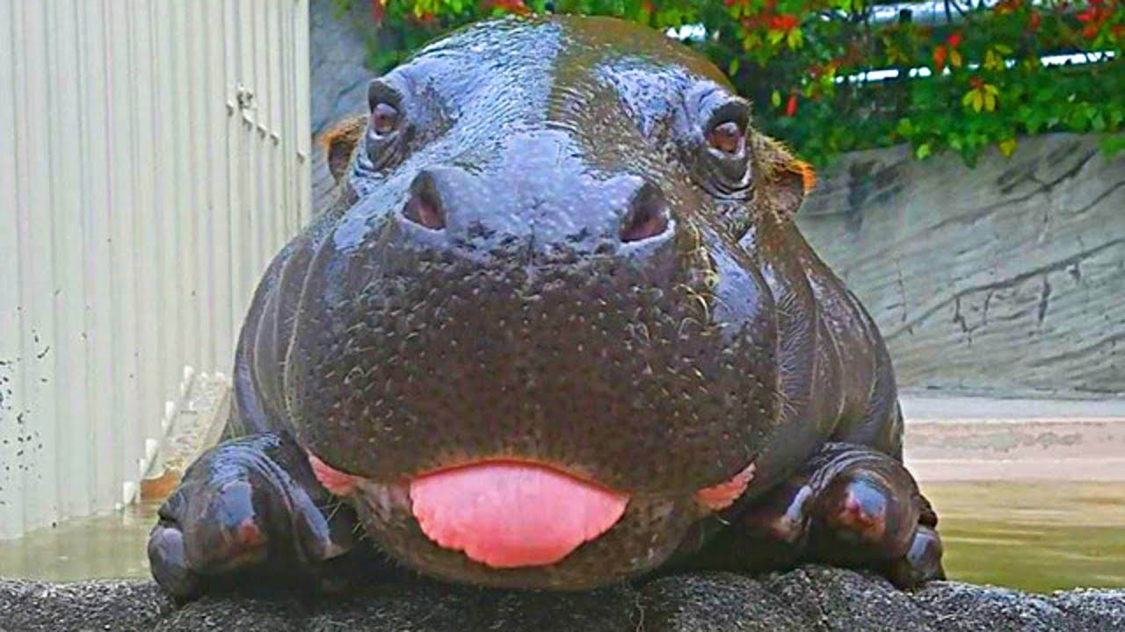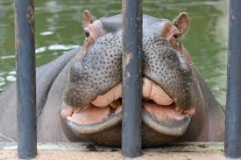
5. Submit one funny and one serious idea for improving this school next year. If the funny one makes me laugh, bonus points. If the serious one is actually something I’m able to implement, mega bonus points!

6. Go to Freetetris.org and get to level 25. Pause the game and take a photo or screenshot and send it to me.

7. What's cookin', Good Lookin'? How about taking us up on our Iron Chef challenge! We would love it if you would make a cooking video of yourself showing us your favorite quarantine recipe with whatever food you already have on hand. Go all out getting in touch with your inner Julia Child, and the more you make us laugh, the better! Be sure to edit it down to under 3 minutes and then email me the video or link.
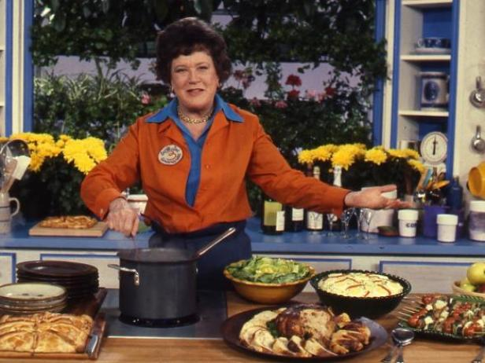

8. Drive by someone’s house and leave a yard decoration of some kind without them seeing you. The bigger, the better. Be careful… the world is full of doorbell cameras and you can’t get caught! Once completed, take a picture and send it to me.

10. Scrabble Challenge: Go to morphthing.com and upload a photo of you to morph with a celebrity. This takes about five minutes to go through their process, but then you get a photo of what it would look like if you and that celebrity had a baby. Click on that image and send it to me and let us all guess who you and the celebrity are.

11. Uno Challenge! What is your ONE best piece of advice for living? Bonus points if it’s actually good advice, mega bonus points if it makes us laugh.

12. Pick another staff member who makes your day brighter each day. Write a short email describing what makes them special and send it to me. I will forward it to them and tell them it is anonymous.

13. Pay it forward: Pick a student who inspires you to get up for work each day. Make a video testimonial or a short email to that student and tell them what they meant to you this year. Send it to them, and a copy to me.

14. The Masked Living Room Challenge! Take a picture or video of your living room, but don’t let it reveal your identity. Send it to me and I’m going to distribute it to other teachers to let them guess whose living room this belongs to.

15. Start a game of Words with Friends with someone from this school. Send me a screenshot after you’ve played an amazing word!

16. Imitation is the best form of flattery. Take a video of yourself doing an impersonation of someone at this school, keep it positive, and send it to me. The better the impersonation, the more bonus points. If it makes me laugh, mega bonus points.
17. Think of a teacher at our school that you admire. Write one paragraph describing why you admire them. Send it to me, and I will forward it to them anonymously.

18. Get anyone in this school to respond “LOL” to one of your texts, but you can’t tell them beforehand that is the response you are looking for. Take a screenshot of it and send it to me.

19. You landed on Club 19!!! Dance. Dance we say. Dance like you are 19 again. Find some music and dance around right now. Plus we’ll give 1 point for anyone you get to dance with you!

20. Jenga Challenge! Find whatever you can around your home and make as impressive a stack as you can. This could be books, chairs, cards…pets??? It’s up to you, but the more impressive, the more points. (If you have kids, they can help too: that should keep them busy!) When finished, take a picture with yourself in the frame, and send it to me.

21. Pictionary Challenge: Draw a picture of something and someone at this school. Once drawn, take a picture of it and send it to me. Let us all try to guess who it is while admiring your artistic prowess.

22. When quarantining, it is important to use art to keep the mind and spirit uplifted. Do an interpretive dance to the song “The Climb” by Miley Cyrus reflecting your journey through social distancing. Use props and have help from anyone you wish. Send me the video when you’re finished.
23. Add a decoration to our Wheel of Fortune Drive-Thru. The bigger, the better! Be sure to take a picture. (If you are not doing the drive thru, copy one of the challenges you do like and repeat it again here)

24. Take a video selfie of yourself recreating the famous scene from The Blair Witch Project, but starting off with, “It’s day 980 of the quarantine…” Keep it under 1 minute and then email me the video or link. Bonus points for the more I laugh!
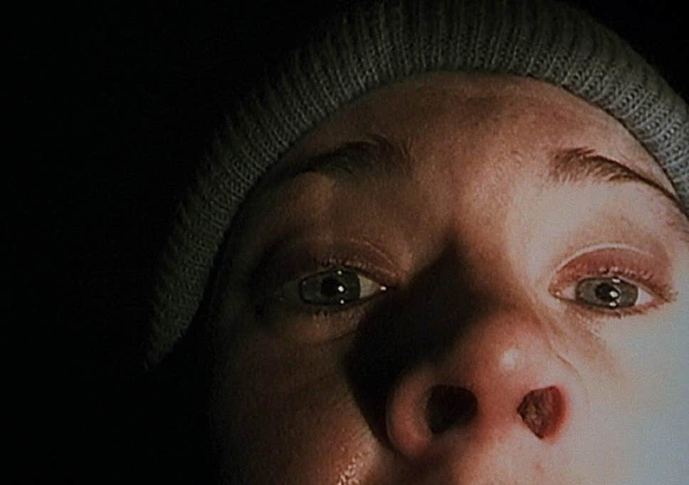

25. Start a game of Words with Friends with someone. Send me a screenshot after you’ve played an amazing word.
26. Who Does This Belong to Challenge! Send me a picture of one of your favorite possessions, or even a pet, but don’t let it show your identity. Include a description. We’ll all guess who it belongs to.
27. Go to your car and make a parody of a ranting video about teachers doing social distancing. You know, the type where you sit in your front seat and give everyone “straight talk.” Just be sure that it is all in good humor and appropriate for us to share with everyone. Then send me the video.

28. Take a picture of your favorite spot in your house or yard and submit - don't forget to tell me why it's your favorite! Bonus points if you get yourself and your family to dress up in unique fashion choices and take a family picture there.
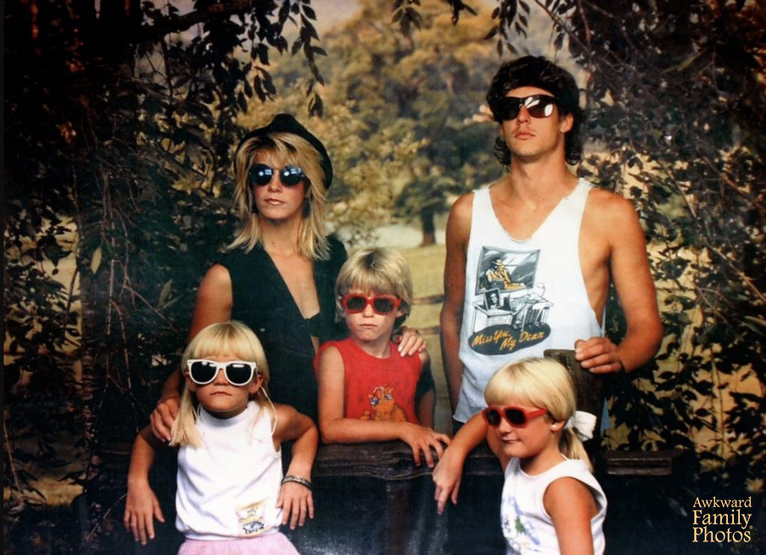

30. Think of a teacher at our school that you admire. Write one paragraph describing why you admire them. Send it to me and I will forward it to them anonymously.
31. Pick a parent of a student who went above and beyond this year. A parent you wish all other parents could be like. Write a short email to them expressing gratitude for their efforts. Email a copy to me and I will forward it to the parent.

32. Who do you consider one of the great teachers at our school? Text them a message saying that you think they are a wonderful teacher, and a brief explanation of why. Send me a screenshot.

33. Scavenger Gift Certificate Challenge! It’s Teacher Appreciation Week and our local businesses love to participate, but they just need someone bold enough to ask them. Call or contact any business of your choice, let them know it’s appreciation week, and ask if they would like to make any offers for our staff. Once you secure something, let me know, and you might just earn mega bonus points if you really pull this off!

34. Think of a teacher at our school that you admire. Write one paragraph describing why you admire them. Send it to me, and I will forward it to them anonymously.
35. How long can you go without technology? Sometime today,turn off your cell phone, tv, and anything electronic. Report back how long you lasted and what it was like (we’re all interested to know, but we can’t bring ourselves to try it!)
36. The Masked Singer Challenge! Record yourself singing a song, this can either be audio or video, but don’t let it reveal your identity. Send it to me and I’m going to distribute it to other teachers to let them guess. Wow us or make us laugh with you, either way, the more you put into it, the more points you’ll earn.

37. Make up the perfect cheer to encourage everyone to stay positive during social distancing. Video yourself and any helpers giving the cheer. Be sure to start off with, “Ready… Ok…” Send me the video, and remember, the better it is, the more I laugh, the more points you earn.
38. Get anyone in this school to respond, “Who is Gary?” to one of your texts, but you can’t tell them beforehand that is the response you are looking for. Good luck. Take a screenshot of it and send it to me.

39. Text congratulatory wishes to someone every few hours throughout today. Get as many other people as you can to do it too. Creative use of memes and gifs is appreciated. Never mention what you are congratulating them for.

40. Write a short poem about our school and send it to me. Be sure to include the word “brouhaha.” Definition: An overexcited response. Good luck!

41. We miss sports. Text at least 3 people from this school by starting off with, “What’s happening, sport?” Let’s see how they reply. Send me the screenshots.

42. Fine art is food for the soul. Paint a picture of the front of our school using only condiments or sauces you already have at your house. Send me a photo. The better the painting, the more points you’ll earn. Also no need to waste it, feel free to use it to dip your lunch or dinner
.
44. Who’s That Baby Challenge! Send me a picture of you as a baby or young child. I will let everyone guess who that beautiful baby grew up to become.

45. Think of a teacher at our school that you admire. Write one paragraph describing why you admire them. Send it to me, and I will forward it to them anonymously.
46. Do the Snoopy dance and get a video of it! Get as many people doing it at the same time as you can.
47. Send me a picture of you that everyone will get a kick out of, perhaps from childhood or high school or on a funny vacation
48. Text your best friend at this school and simply tell them that they are your best friend.
49. Make a virtual lunch date with someone you normally eat lunch with at school. Catch up either through texts or video.
50. Text birthday wishes to someone every few hours throughout today. Get as many other people as you can to do it too. Creative use of memes and gifs is appreciated. Never acknowledge that it’s not really their birthday. Send me a screenshot of one of their humorous replies.

