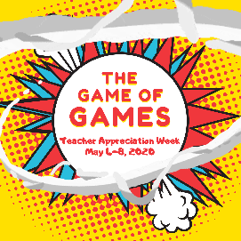
How to Spin

Stay in your car.
Clap as the wheel spins and repeat, “Big prize. Big prize. Come on BIG PRIZE!!!”
If the wheel lands on “BIG PRIZE!!!” scream and honk your horn and say things like, “I NEVER THOUGHT THIS WOULD HAPPEN TO ME!!”
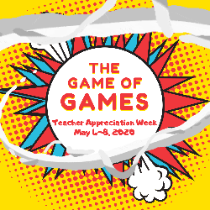
Welcome to the Bonus Round!

Take a deep breath.
Clap as the wheel spins and repeat, “Come on! Come on! One time! One time!”
When the wheel stops on a number, you get that prize and you also get to add more points to your score!

